**Volume XIIII, Number 8**

**Minutes of the Faculty Senate Meeting**

**June 10, 2021**

1. **Call to Order and Roll Call**

The meeting was called to order by President Steve Raper. Roll was called by Secretary Kathryn (KC) Dolan. Those whose names are grayed out below were absent.

Akim Adekpedjou, Julia Alexander, Venkat Allada, Stuart Baur, Jeff Cawlfield, Amitava Choudhury, Steve Corns, William Fahrenholtz, Mahalet Fikru, Darin Finke, Mark Fitch, Samuel Frimpong, Michael Gosnell, Sarah Hercula, Sarah Stanley for Mike Hilgers, Kelly Homan, Ali Hurson, Matt Insall, Ulrich Jentschura, Kurt Kosbar, K. Krishnamurthy, Ashok Midha, Cassie Elrod for Fui-Hoon (Fiona) Nah, Parthasakha Neogi, Jonathan Obrist-Farner, Lonnie Pirtle, Jorge Porcel, Steve Raper, Prakash Reddy, Melissa Ringhausen, Chaman Sabharwal, Joel Burken for William Schonberg, Michael Schulz, Sahra Sedigh Sarvestani, Kathleen Sheppard, Jeff Smith, Nancy Stone, Shoaib Usman, Jee Ching Wang, David Westenberg, Daniel Willis, Maciej Zawodniok

**II. Approval of Minutes**

The minutes of the April 29 meeting was distributed prior to this meeting.

A motion was made to approve the minutes.

*Motion passes.*

**III. Campus Reports**

**A. Staff Council**

Amanda Kossuth, Staff Council President, spoke and said this will be her last meeting as President. Elections start next week, and the new President will start July 1. Staff council held their first in person meeting of the academic year on June 10, 2021.

**B. Student Council**

Amanda Aiken is the new student council (StuCo) president. StuCo has been busy communicating with students the importance of getting vaccinated and then reminding students to indicate they have been vaccinated on their health portal.

**C. Council of Graduate Students**

No report.

**IV. President’s Report**

Faculty Senate President Steve Raper presented and acknowledged that this is his last meeting serving in the role as Faculty Senate President. Steve thanked the other officers for their help with keeping him on task and appreciates the patience as well as the administrators. The past year has been interesting and the faculty rose to the occasion. There have been great challenges and many stressors. The students and staff rose to the occasion and we lost many due to budget cuts.

IFC will now be called Inner Faculty Cabinet and Steve Raper will be the IFC chair. It will be interesting because Steve Graham is retiring effective August 1. One topic discussed was shared governance and what that means at the University of Missouri System. There will be a subcommittee looking deeply into shared governance and look at getting some reports.

Stephen Corns was recognized as being the past president and being an asset to Faculty Senate and the campus.

Commencement will be held on July 31 for the students who have not gotten to attend a commencement.

The last item is a question directed to faculty members and administration of where do we go from here? There have been a lot of changes in leadership. There is a new Provost, Colin Potts. There is a new CFO and perhaps other changes.

Sahra Sedigh Sarvestani said that she was on the Academic Planning Committee (APC) last summer and many hours were spent addressing that very question about where we go from here. Dr. Sedigh Sarvestani mentioned she had asked in the past about what happened to all of the work. Dr. Sedigh Sarvestani asked if we are we sticking to that plan, do we even have a plan? In her opinion, the question should be, are we sticking to our plan, does our plan need revisions?

Chancellor Dehghani responded by saying, as you say, a plans or plans are made to be changed and updated. There was no year like this past year given everything that we had to do. This year was the year of predict and correct. The good news is that we have a new chief academic officer on board. The Chancellor said he was waiting to see where we go from here, just like you: what are the new programs, what are the new academic programs? We have to remember our Northern star. One of the big elements that we have to remember is our goals. We want to be a campus of 12,000 students, which means building the infrastructure, building the faculty support, and building the admin support for us to be enabled to get there. Until we get the enrollment, we can’t really add faculty or vice versa. Understanding the research retention and ranking is very important. Hopefully, this new year, we are going to have a different number of circumstances to deal with, if I may say, a more normal set of circumstances to deal with than we had in the last.

Ali Hurson mentioned that there has been some concern about the way the faculty has been evaluated this year. The faculty had many challenges, and then the faculty members have been evaluated based on parameters that aren’t necessarily in their control. This unfair evaluation of the faculty which came from the top

The Chancellor responded by saying, we don't have a perfect tool. Nonetheless, there has to be a way of evaluating and if it's unfair, it's unfair across the board I’m not trying to make any excuses for them, but we don't rely on only one year’s evaluation. There is a history of performance, and when I say top 10% or bottom 5%, I don't really mean that this is for just a one-year period. The decision has to be made by the departments themselves who know the faculty member way better than any assessment tool. It was a tool that they've been using all along and we have used it all. This last year was different circumstances. I never got engaged with designing a tool for performance evaluation of faculty members, for example.

Ali Hurson stated the faculty teaching evaluation is based on a student evaluation and with all the information which we have, there is a lot of evidence that student evaluation is not a valid metric to evaluate teaching effectiveness of a faculty. If it’s an unsatisfactory teaching evaluation, that is going to be reflected as unsatisfactory performance for the year.

Michael Schulz asked the academic report Sahra mentioned be on the agenda for the next meeting to discuss and to have it distributed among the senators.

**V. Administrative Reports**

1. **Chancellor’s Report**

Chancellor Dehghani started off by thanking everyone for their overwhelming support reflected on the administrative review. There were some unfair comments regarding things that were out of his control. There was some wonderful constructive criticism.

For compensation, campus is excited about the fact that this year will raises.

The state of the university is in great shape and Missouri S&T just received full recognition from the governor’s office that S&T is the manufacturing center for the UM System. The governor awarded $5 million for design development and building of an advanced manufacturing facility. Next week a meeting is planned with Senator Bond to request additional funding.

Enrollment is up and retention is higher. In places like China and India they have not been granting visas but the India has starting issuing again.

The arrival district funding initiative is complete after receiving the last 2.5 million needed.

On Wednesday, June 23 at 1pm there will be a memorial celebration of life for Fred Kummer at Hasselmann Alumni House.

On October 9, which is the anniversary of the gift from Fred and June Kummer, there will be a major celebration of life for Fred Kummer.

1. **Provost’s Report**

Provost Potts presented and thanked everyone for being so welcoming. Steve Roberts has been extremely helpful and gracious during the transition period as well as Kelly Homan and Steve Raper.

In regard to the Provost’s role in shared governance and working together, Colin would like everyone to hold him to what he is saying. Colin’s vision regarding governance is to get things done, planned, deliberated, and accomplished. Shared governance is a model where faculty own some of that process and there has to be communication and interaction.

**VI. Reports of Standing Committees**

1. **Curricula**

Steve Raper presented on behalf of the Campus Curricula Committee (CCC). The committee met on May 4. The committee reviewed 13 course change forms, 39 program change forms, 4 program change forms were reviewed for administrative/clerical updates only and 2 experimental course requests.

The CCC moved for Faculty Senate to approve the 39 program change forms and 13 course change forms.

*Motion passes.*

1. **Facilities Planning**

Kelvin Erickson presented on behalf of the Facilities Planning Committee (FPC). The committee shared a progress update regarding the arrival district progress. Major projects include demolition of the Bureau of Mines buildings (BOM), innovation lab construction, and university drive construction. The abatement scope for the BOM buildings is done. The University is working with the State Historical Preservation Office regarding BOM 1. Bids have been received for the demolition and it is expected to take 120 days to complete. Demolition is scheduled to start July 1. The innovation lab is in the design phase. The programming phase is complete, and the project is in schematic design. The Innovation Lab will have over thirty thousand square feet of usable space. The contract was awarded by the City of Rolla for the construction of the university drive and the roundabout.

1. **Budgetary Affairs**

Mark Fitch presented on behalf of the Budgetary Affairs Committee (BAC). The continuing referrals include the big picture balance sheet, current and next FY budget, and salary changes. The current FY ends on June 30 and remains on target.

For the general revenue budget, tuition is down a little bit but the discount rate is also down. The budget looks like state appropriations is larger but actually system will give campus more money but then charge the campus fees for system services. The CARES act fund received 3.4 million that will mainly be used for IT. The budget reflects a 2% raise in the total.

For general revenue budget: costs, the benefit expense is not increasing as much as normal, however, the way things are calculated is changing. “Other Expenses” are returning to what they were pre-Covid.

The BAC looked at salaries and presented that there was a 10% cut during the summer of 2020 in the salaries of the top administrators. Chancellor Dehghani was given a significant raise of $100,000 on March 1. The top communications person was made into an assistant Vice Chancellor and received a 32%/$35,920 increase. The director that got the CDO position got a 23.6%/$23,843 increase. With the shuffle of the CASB Deans, individuals saw raises, but the overall budget showed a slight decrease in totals.

The BAC displayed salary changes in positions reporting to the Chancellor and to the Provost; for the positions that report to the Chancellor you will see increases found in those positions. Chancellor Maples was paid less than the previous Chancellor in his interim position. Chancellor Dehghani was paid the same as the previous Chancellor. There was a 3% increase in the current academic year because most of the salary changes happened in September which goes along with the academic year.

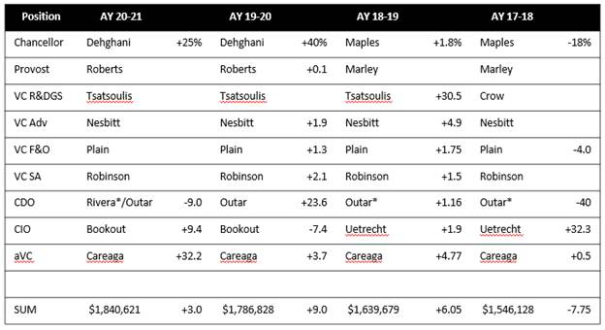

For the positions that report to the Provost, there are big percentage changes, but those changes aren’t big as dollars. There were new positions that resulted in small salary changes overall.

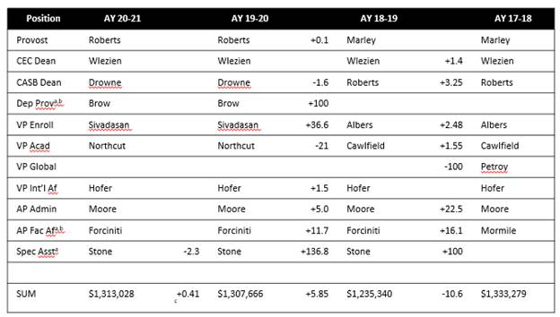

For directors, there were two who were given raises based on equity. The budget director got a $18,575/22% increase and the police chief got a $11,400/10.4% increase.

The chairs had no increases except for Kwame who was promoted to Professor.

For department chairs raises in AY 19-20 were 1.5 – 2.6% except: 1 of 11 in CASB and 4 of 9 in CEC:

* ALP:                                     +  6.6%          AY 20-21
* CArE:                                     +4.1%           Merit, AY 19-20
* ECE:                                       +3.3%           Merit, AY 19-20
* GGPE:                                    +5.5%           AY 19-20
* MNE:                                     +5.6%           AY 19-20
* Ignores 10 chairperson changes in last two years (Econ, History, Math, TEC, ChE x 2, Comp Sci x 2, MAE, MNE)
* Ignores ROTC commanders, not S&T funded

For faculty there was a 0% raise in AY 20-21. The information below does not include lecturers, research NTT, or Chancellor’s professors in the numbers.

AY 2020-2021

* 0% raise, few merit, several promotions (+10K for P, +6K for TP, +5K for AP, +3K for ATP)
* CS, two aP in second year: +12.5%, + 50%
* GGPE one P +1.2%, one P +7.8%
* MSE one P -7.7%, one +10%
* MAE: one P -5.2%, one AP +6%

AY 2019-2020

* Dep’ts varied, instructed to use 1.5% for all, then 0.5% to top quarter
  + Dominant model was 1-1.5% for many, 3-6% for the rest
  + All 1.5% except one/few below 1% and one/two above 5% (ChE, MAE)
  + 0% for a few, 2-4% for the rest (ALP)
  + 0.5-1.5% for most, 5-8% a few (Emgt, GGPE, MNE)
  + 1.5% several, 2.0% several, 5% one, 30% one (CS, much churn)
* One MAE AP +9.4%; two MSE P +10%

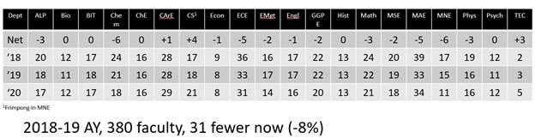

1. **Information Technology and Computing Committee**

John Singler presented on behalf of the Information Technology and Computing Committee (ITCC). The main topic of the ITCC presentation will be the budget and some faculty senate referral updates. There is currently an effort to increase IT salaries towards market level for current and open positions. IT has had trouble hiring and retaining people at S&T and many other universities. There is one-time coronavirus money that is being used on infrastructure.

There is a new draft of the desktop enhancement policy in development. There are many details to work out but essentially, each IT machine will come with a 4-year warranty and IT will only work on machines under warranty. The re-deployment program will no longer exist because it will not be financially feasible.

Reopening the IT walk-up helpdesk is a top priority. After the helpdesk is fully staffed, the next focus will be on the call center.

Faculty Senate made a referral to ITCC asking for information about the green screen classrooms. An ad-hoc committee has been formed and is working on this. The committee asked department chairs for feedback and found if the green screen rooms are used correctly, they do have the means to produce high quality content. The main benefit is corporate partnership short courses. They did not see a great benefit for general teaching.

Another referral from faculty senate regarding myVita was received. How was myVita chosen and what is the cost. In the 2014 ITCC and faculty senate minutes, and there was mention of myVita. There was a presentation, but it was never endorsed by faculty senate. To find out more, UM System was contacted and said in 2012 town hall meetings were held at each campus and UM System sent academic affairs representatives to visit with faculty. The CIO was not looped in on this decision and was looped in after the purchase was made. There is now a related system, RPT, which will now be used for promotion and tenure cases. In 2019 there was a demo and faculty were involved.

1. **Public Occasions**

Sahra Sedigh Sarvestani reported on behalf of the Public Occasions Committee (POC). The POC is presenting a motion to approve the 2021-2022 open house dates.

*Motion passes.*

**VII. New Business**

No new business.

**VII. Adjourn**

The meeting adjourned at 3:03 P.M.

Respectfully submitted,

KC Dolan, Secretary